# Measuring battery voltage on Arduino Uno board

This documentation is supplied with the Arduino SDK heart rate example.

The method of measuring the battery voltage on an arduino board is to connect a voltage divider like shown in Figure 1. The ADC reference voltage in the example is set to 1.1V so the voltage range exposed to analog input pin 0 (A0) should be 0-1.1V.

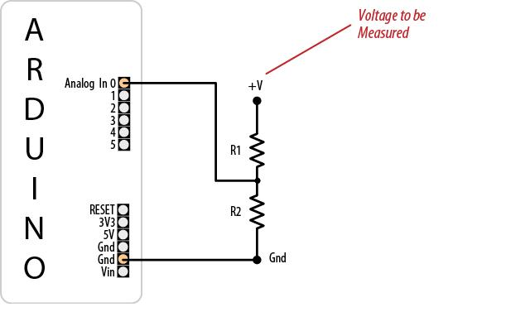

Figure 1. Setup of voltage divider for the Arduino Uno

The battery shield used provides 9 volts so the voltage divider is calibrated in a way that A0 voltage is 1.1V when battery voltage is 9V. For the ADC, it is recommended to set impedance seen by the A0 to be maximum 10k in order to obtain accurate enough ADC reading. However, it is beneficial to have the current through the voltage divider as small as possible in order to not waste excessive battery energy. To meet these requirements the voltage divider can be set up with the following values for 9V supply voltage:

R1: 71.8kΩ

R2: 10kΩ

This will draw current of 9/81.8k=110uA. If this current is to large, one can provide switch to turn on current through the voltage divider momentarily before ADC sampling.

A battery shield compatible with the Arduino Uno board is available at battery-shield.com.